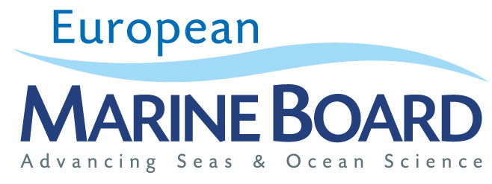

Application to become a member of the European Marine Board IVZW, a Non-Profit International Association under Belgian Law
European Marine Board IVZW (Internationale Vereniging Zonder Winstoogmerk)
Registered Office: Wandelaarkaai 68, 8400 Ostend, Belgium
Register of legal entities (Brussels) 0650.608.890
(hereinafter the "Association")

Dear Prof. Dr. Jan Mees,
I, [Insert Name of Legal Signatory], as an authorized representative of [Insert Name and Legal Form of Applicant Member Organization], having its registered office at [Insert Address of the Registered Office], registered with [registration authority] under the number [number] (hereinafter, the "Applicant");
acting as designated representative of the consortium [Insert Name of the Consortium] consisting of the entities as further described in Annex 1 (the "Consortium”);
hereby make a formal application for the Applicant to become a member of the Association on behalf of the Consortium in accordance with Article 6 of its Articles of Association.
As requested by Article 6.3 of the Articles of Association of the Association, you will find an accompanying letter that demonstrates our significance in terms of national or European support for marine science and/or marine research output including the reasons for joining the Association. I remain available should you have any further questions in this respect.
Subject to approval of this application for membership, the Applicant hereby appoints the following individuals as its representatives with the Association for a three -year term from the date of the admission of the Applicant as member of the Association:
Delegate: [Insert name of EMB delegate]
Address: ________________________________
________________________________
Email: ________________________________
Telephone: ________________________________

Alternate (optional) : [Insert name of proposed Alternate]
Address: ________________________________
________________________________
Email: ________________________________
Telephone: ________________________________
In making this application, I confirm that I accept the terms and adhere to the Articles of Association of the Association.

Signed for the Applicant:
Signature: _________________________________
Capacity: _________________________________
Date: _________________________________
Stamp of the Applicant:

Annex 1
Composition of the Consortium

Name of the Consortium: ___________________________________

Members of the Consortium: (please use additional pages as required)

- Name: ____________________________________

Address: _____________________________________

- Name: ____________________________________

Address: _____________________________________

- Name: ____________________________________

Address: ______________________________________

- Name: ____________________________________

Address: ______________________________________

- Name: ____________________________________
Address: ______________________________________

- Name: ____________________________________
Address: ______________________________________

- Name: ____________________________________
Address: ______________________________________

- Name: ____________________________________
Address: ______________________________________

Belgian Act of 27 June 1921 on non-profit associations, non-profit international associations and foundations.
In accordance with Article 6.2 of the Articles of Association, one of the universities or higher education institutes that are part of the Consortium should become a member on behalf of the Consortium.
In accordance with Article 6.1 of the Articles of Association, the Consortium should consist of at least three universities or higher education institutes from the same country of origin, involved in marine research which jointly represent a significant proportion of the higher education marine research effort of the country of origin.

